Intake Process

Version | Name | Date of Change | Comments
1.0 | Colin Higgins | 02.18.2021

Introduction
The primary goal of the Intake Process (“the process”) is to qualify applications for the upcoming iterations, and to ensure an application is ready to migrate to Azure before an architect is assigned. The minimum qualifications that an application needs to have before it is assigned to the Intake team is: confirmation of application owner(s), migration month, and confirmation that the application is to be migrated – should not be assigned if the application is to be decommissioned within 90 days or is currently in the sunset process.

Intake checklist
There are pre-requisite steps that must be completed prior to conducting the Architecture Review for a given application. The Architecture Review can be scheduled, but cannot be completed, without conducting the introductory/overview call and receiving the completed Welcome Kit back from an application owner. Each of the below items must be completed before scheduling the Architecture Review.
- Confirmation of the Application Owner
  - Before an application can be assigned to the Intake Team, the Providence Team (VTeam Leads) will confirm the correct application owner is recorded on the App Card (pulled from Service Now) in the .INTAKE ADO board.
- Welcome Kit is sent to the Application Owner(s)
  - The Welcome Kit is sent to the Application Owners approximately 2 weeks prior to the upcoming iteration. It is expected that the correct application owners are provided on the Application Card before the TOM sends out the Welcome Kit.
  - If the Application Owner is incorrect or unresponsive, due diligence is required to identify the correct owner should occur before moving application to the Constrained board.
  - Welcome Kit Sent date is updated on the Application card > Key Dates tab
  - 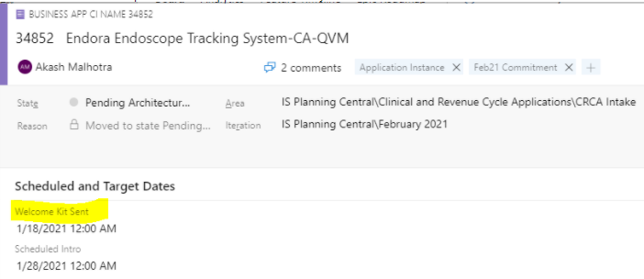
- Introductory Call is scheduled
  - No more than 2 days after the Welcome Kit Sent date, another contact should be made to the Application Owner(s) to schedule and intro/overview call to gather preliminary information about the application
  - Once the intro/overview call meeting is scheduled, the Scheduled Intro date is updated on the Application card > Key Dates tab.
  - 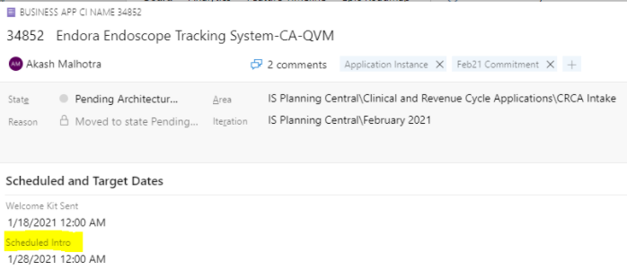
- Introductory Call is conducted
  - The goal is to have the intro/overview call completed before the new iteration month
  - The application owner must attend this meeting but do not need to have the Welcome Kit completed to move forward with the call.
  - The Architecture Review Scheduled date should be determined during the Intro Call
  - Actual Intro Completed Date is updated on the Application card > Key Dates tab
  - 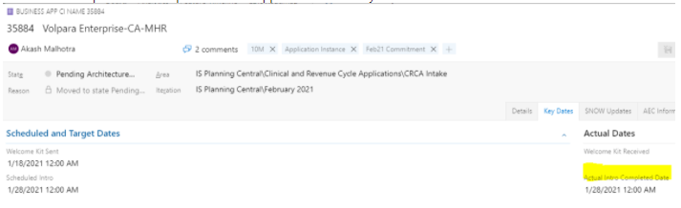
  - Add any pertinent notes to the comments on the application card
- Architecture Review date is scheduled
  - The agreed upon date to conduct the Architecture Review is discussed during the Intro Call with the application owner(s).
  - The meeting invite is sent to the application owner(s) and the 10M architects
  - First Scheduled Architecture Review Date is updated on the Application card > Key Dates tab
  - 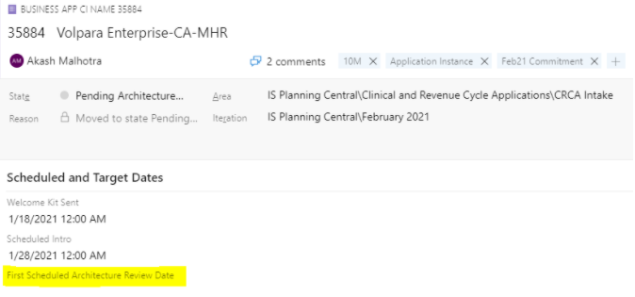
- Welcome Kit is returned
  - Show Stopper - the Welcome Kit must be returned before the architecture review meeting can be conducted
  - If the Welcome Kit has not been returned (completed) 2 days prior to the scheduled architecture review date, reach out to the application owner via Teams, and reschedule the meeting to a later date – architects need time to review the server information.
  - When the Welcome Kit is returned, update the Welcome Kit Received date on the Application card > Key Dates tab
  - 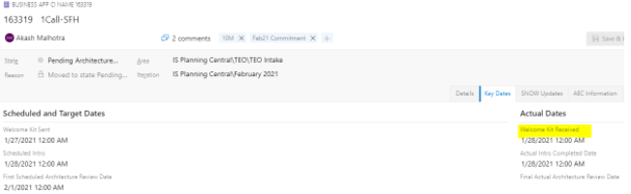
- Architecture Review
  - This meeting cannot be conducted unless the above have been completed: Application Owner confirmation, Welcome Kits have been sent, Intro call has been scheduled and conducted, Arch Review is scheduled, and the Welcome Kit has been returned to the TOM
  - Final Actual Architecture Review Date is updated on the Application Card > Key Dates tab (date is added by the architects).
  - 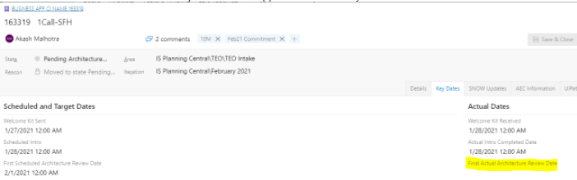

Happy path process
[insert process flow from app assignment lift and shift board]

Providence ado board navigation
The Intake board is owned by the Providence team and managed with the help of the 10th Magnitude TOMs. There are a total of 8 columns on the board overall, but only 4 for the TOMs to manage. Any time an application card is moved from one lane (or another ADO board) to another, a comment must be added to that application card.

Needs WK/RA Emailed
The expectation is that once an application is assigned to the 10M team for an upcoming iteration, the application will reside in this column until the Welcome Kit is emailed to the listed application owner. Once the Welcome Kit is sent out to the App Owner, the TOM will update the "Welcome Kit Sent" date [see Intake Checklist] and move the app card to the Needs WK/RA/AR Scheduled column on the ADO board.

May Need Escalation
Any application card that may need intervention from the Providence team should be moved to this column on the ADO board. Examples of this are:
- Inability to confirm application ownership
- Application will be decommissioned but no retirement date can be confirmed
- Dependencies with other applications (or projects)
The 10M TOM should perform their due diligence to resolve any impediment before moving the application from the Intake to the Constrained board.
Needs WK/RA/AR Scheduled
The Welcome Kit has been sent out to the application owners and the intro call is scheduled and/or has been conducted. The application card remains in this column until the architecture review is scheduled.

Waiting for RA/AR
Applications are moved to this column after the intro call has been conducted and a date has been scheduled for the architecture review. The Welcome Kit does not necessarily need to be returned to move into this column, but the architecture review cannot be conducted without the Welcome Kit.

Once a card is moved to this column, the application instance will then need to be added to the internal (10M) ADO board:
  - Create the parent card
  - Add the instance to the parent card
  - Include the date of the arch review, application owner, and all the comments from the app card on the intake board to the child card on the internal board
  - Drag new card to the Intake column on the internal board

Internal ADO Board Navigation
The Internal ADO is used by the 10M architects to track their assigned applications. An application (and its corresponding servers) is only added to the Internal ADO board when the Architecture Review is scheduled (Waiting for RA/WK column on Intake board).

The TOM will access the Internal ADO (application) board and add the parent application in the “New” column. The name of the parent should not be the same as the instance, but rather generalized name because there may be similar application instances assigned in the future. For example, the instance name “ImageStream-Kadlec” should name the parent “ImageStream”.

The child name should be linked to the parent and titled the app instance name. There are a few fields that are required when creating the child: Arch Review Scheduled (DD/MM/YYYY), App Analyst, and any comments carried over from the Intake application card

It will be the responsibility of the Architect to move the application card from the Intake swim lane, on.

moving app out of intake board
The expectation for applications on the Intake board is that the information provided on the app card is accurate and that the application is ready to migrate to Azure as a Lift and Shift. This is not necessarily what occurs, therefore applications are moved out of the Intake board and reassigned to another team/board. As an application card is moved to another board, the State is changed.

Pending Architecture Review
This is the state of all the application cards included on the .INTAKE ADO board.

Pending Decom
This state is added to any application that the app owner identifies as needing to decommission or is in the sunset process. This state requires the "Target Retire Date" field filled out in the Key Dates tab.
- > 90 days - application owner will need to provide the expected date
- < 90 days - set the date to 90 days into the future; attempt to migrate to Azure anyway
The Area path should be changed to CRCA/STE Decom and assigned to Cassandra Gross.

We need to ask the app owner for the IDEA number for any applications that are slated to be decommissioned. The application owner should be able to provide this by end of day, otherwise the app will move forward with being lifted and shifted.

If the application needs data retention, then lift and shift will need to occur.

Constrained
Applications that are constrained for any reason such as an unresponsive app owner or an app owner who indicates they will not migrate in the assigned iteration, are assigned Constrained state. Comments must be included and the Fantastic 4 (Ron Dike, Steven Lord, Bill Yockell, and Alex Pospical), plus Wilson Rodriguez, must be tagged.

The aim should always be to keep an application on the Intake board and push through with the migration in the assigned iteration. Do not move to the constrained until you have exhausted your option to resolve an impediment.

Migration In-Progress
Applications that have the Arch Review completed (and moved off the Intake ADO board) are assigned the Migration In-Progress state. This signifies that (Lift & Shift) work is on-going for that migration.
The 10th Magnitude team will only be migrating application that are Lift and Shift, no Refactor. It is the 10M architects’ responsibility to move applications from the Intake board to the Lift and Shift board after completing the architecture review.

Refactor
Applications that are not a simple Lift and Shift (migrate as-is) are to be moved out of the Intake board and to the Refactor board. An application is typically identified as either a Refactor or Lift & Shift prior to the architecture review. On the off chance that an application is discovered to be a Refactor during the architecture review, the architect will inform the TOM. The TOM is responsible for moving an application from the Intake board to the Refactor board. The same is true on the Internal ADO board.

Constraints
The Pre-Architecture Review Checklist must be completed prior to conducting the Arch Review meeting. On the way to completing this checklist, there will be impediments such as an unknown/incorrect/unresponsive application owner, incorrect iteration, or unreturned Welcome Kit. These constraints can be remediated with a quick email or Teams message, but if the issue lingers too long, the application will be moved to the Constrained board. The 10M TOM should do everything in their ability to keep the application on their Intake board.

Unknown/Incorrect/Unresponsive Application Owner
If you contact an application owner requesting them to fill out the Welcome Kit (or conduct the introductory call) and they indicate that they are not the owner, you should contact the Prin IS Apps Analyst at Providence to help locate another app owner. You can find the Prin IS Apps Analyst by following these steps:
- Navigate to the Providence’s Service Now (SNOW)
- Go Business Applications and search for the application in question
- Identify the IT Strategy Leader in the Owner tab
- Go to Providence’s Teams and search the IT Strategy Leader
- Click on the organization icon 
- Locate the person with the title “Prin IS Apps Analyst” 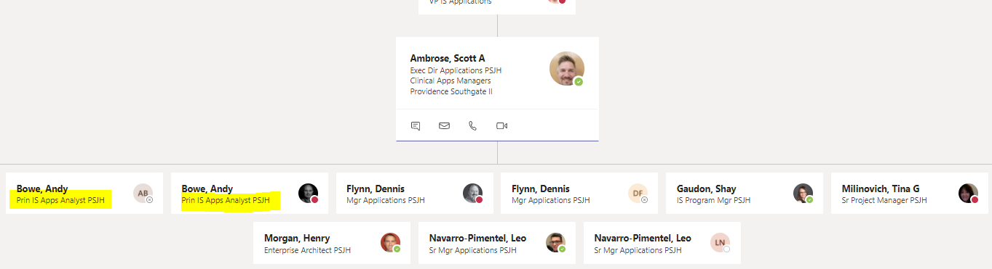

If that analyst is unable to assist you then application card will need to be bounced to the Constrained team.
- Change the State to Constrained
- Update the top-level constraint pattern to APP TEAM DELAY
- Update detailed constraint category to OWNER NOT COMPLETING MIGRATION
- Add a constraint note
- Add a comment summarizing in detail what is happening
- Blow away the current App Contact on the card (because it is unknown)
- Change the Area to CRCA Constrained Apps or STE Constrained Apps
  - take note of which team is currently assigned: CRCA or STE. This will dictate which Area the card is reassigned to
Welcome Kit is not returned within 7 days of sent date
The Application card automatically turns YELLOW if a Welcome Kit Received date is not added within 7 days of the Welcome Kit Sent date. At this point, you should send the application owner a message in Teams for an expedited response and move the card to the MAY NEED ESCALATION swim lane.

If the Welcome Kit is not received, or no response is given after 2 days, the State of the card should be changed to Constrained.
- Change the State to Constrained
- Update the top-level constraint pattern to APP TEAM DELAY
- Update detailed constraint category to OWNER NOT COMPLETING MIGRATION
- Add a constraint note: owner not completing migration
- Add a comment "did not reply to contacts" and tag Bill Yockell, Steven Lord, Ronald Dike, and Alex Pospical
The 10M TOM should exhaust their resources before moving to constrained: email app owner and their VTeam Lead, and direct Teams message.
Bad Plans
Any time an application is considered “constrained”, the 10M TOM will add the application to the “Bad Plans” report within the Intake Team Teams channel. This report is used to track which applications were not planned appropriately prior to assignment to the Intake Team.
The application is constrained when: the application owner provided on the application ADO card is incorrect, the application is scheduled to be decommissioned/sunset within the next 90 days, application is a software as a service, a physical device and not an application, or the application team is not ready to migrate in the listed iteration due to other dependencies.
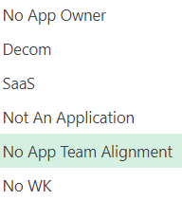
The Bad Plans report is used to provide data on poorly planned applications that are handed off to the Intake team.
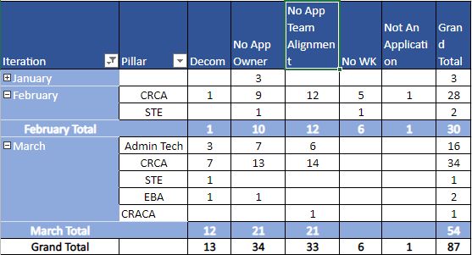

Contacts
Title | Name | Email
Client Partner | Andrew Hill | Andrew.hilll@providence.org
Delivery Director | Akash Malhotra | Akash.Malhotra@providence.org
Technical Onboarding Manager | Mohammad Ghouri | Mohammad.Ghouri@providence.org
Technical Onboarding Manager | Colin Higgins | Colin.higgins@providence.org
Architect | John Ozarchuk | John.Ozarchuk@providence.org
Architect | Marquis Wynne | Marquis.Wynne@providence.org
Architect | Tuan Pham | Tuan.Pham1@providence.org
CMC Engineer | Mason Adams | Mason.Adams@providence.org
CMC Engineer | Kyle Dougherty | Kyle.Dougherty@providence.org

